PROJECT SUMMARY
Stroke Risk & Determinants Analysis
Python • SQL • Power BI
OKPALIKO, NCHEDOCHUKWU ANASTASIA
GITHUB:github.com/Nchedochukwuanastaia22

SLIDE 1 — PROBLEM STATEMENT
Stroke remains a leading cause of death and disability.
Understanding its key drivers is critical for prevention and healthcare planning.
This project analyzes patient data to identify risk factors and inform decisions.
SLIDE 2 — PROJECT OBJECTIVE
- Identify major determinants of stroke
- Analyze relationships between risk factors and outcomes
- Perform structured analysis in SQL
- Build an interactive Power BI dashboard
- Provide actionable recommendations
SLIDE 3 — DATA & TOOLS
Dataset: Healthcare Stroke Dataset (CSV)
Tools Used:
- Python (Jupyter Notebook) – Cleaning & loading
- SQL (SSMS) – Analysis & querying
- Power BI – Visualization & reporting
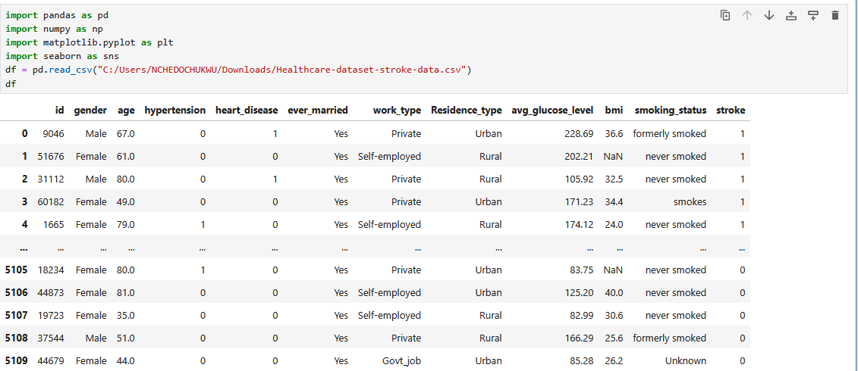
SLIDE 4 — STEP 1: DATA CLEANING (PYTHON)
- Loaded CSV into Jupyter Notebook
- Handled missing values (BMI)
- Standardized categorical fields
- Checked for inconsistencies and outliers
- Prepared data for SQL import
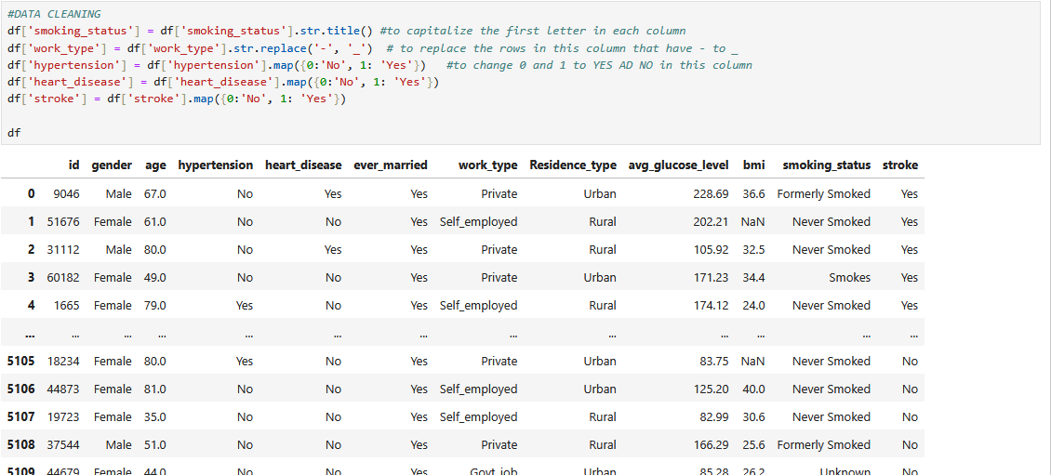
SLIDE 5 — STEP 2: LOAD DATA TO SQL
Connected Python to SQL Server
Created structured SQL table
Inserted cleaned dataset into database
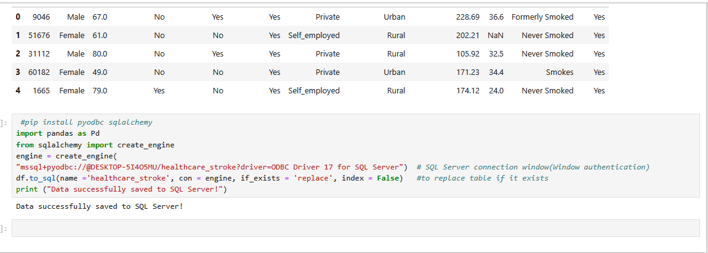
SLIDE 6 — STEP 3: SQL ANALYSIS (SSMS)
Key analyses performed:
Stroke distribution by age, gender, residence
Impact of hypertension & heart disease
Stroke rate by smoking status & work type
High-risk patient profiling
Combined comorbidities analysis
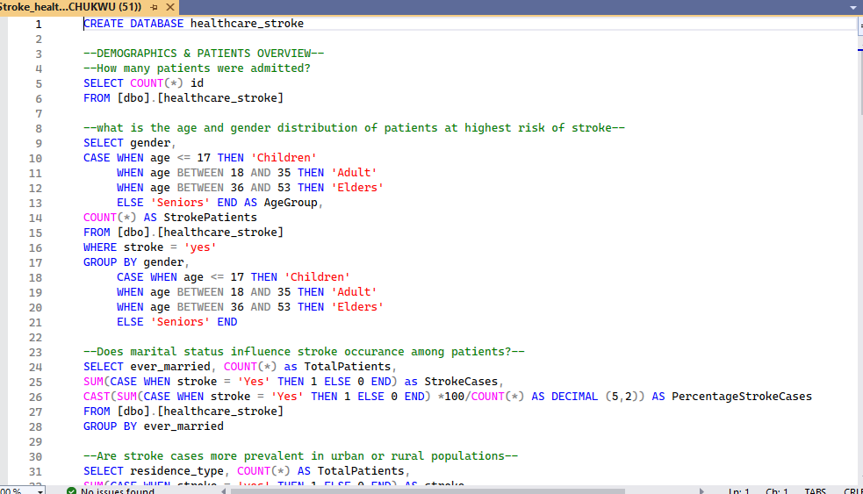
SLIDE 7 — STEP 4: POWER BI INTEGRATION
Connected Power BI to SQL Server
Built data model
Created calculated columns & measures
Designed multi-page interactive dashboard
SLIDE 8 — DASHBOARD STRUCTURE
Dashboard Title:
Stroke Risk & Determinants Analysis
Pages:
Demography (Patient Profile)
Stroke Distribution & Risk Factors
Insights (Metabolic & Geographic Patterns)
SLIDE 9 — PAGE 1: DEMOGRAPHY
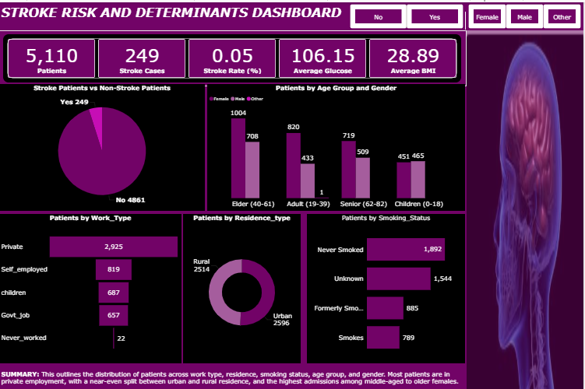
Key visuals:
Patients by Work Type
Patients by Residence Type
Patients by Smoking Status
Patients by Age Group & Gender
SLIDE 10 — PAGE 2: STROKE DISTRIBUTION & RISK FACTORS
Visuals included:
Stroke rate by Work Type (Funnel)
Stroke rate by Age Group & Gender (Bar)
Stroke rate by Smoking Status (Pie)
Stroke rate by Hypertension (Pie)
Stroke rate by Heart Disease (Pie)
SLIDE 11 — PAGE 3: Risk Stratification
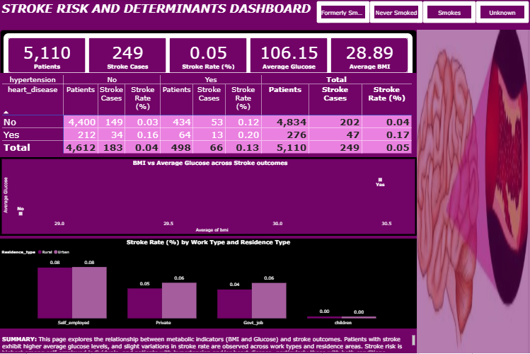
Visuals included:
BMI vs Average Glucose (Scatter, colored by Stroke)
Stroke rate by Work Type & Residence
SLIDE 12 — KEY FINDINGS
Highest stroke risk: Seniors (61–82)
Heart disease: 17.03% stroke rate
Hypertension: 13.25% stroke rate
Former smokers: 7.91% stroke rate
Higher glucose levels observed in stroke patients
Self-employed group showed highest stroke incidence

SLIDE 13 — BUSINESS IMPACT
This project demonstrates:
Strong data cleaning in Python
Structured analytical SQL skills
Professional Power BI dashboard design
Ability to translate data into actionable insights
SLIDE 14 — RECOMMENDATIONS
- Prioritize screening for 61+ patients
- Improve hypertension & heart disease management
- Promote lifestyle interventions for high BMI/glucose
- Strengthen anti-smoking awareness
- Allocate resources to high-risk groups
SLIDE 16 — CONCLUSION
End-to-end analytics project from raw data to insights.
Supports data-driven healthcare decisions.
Showcases professional data analyst capabilities.

